Before -

Desktop –



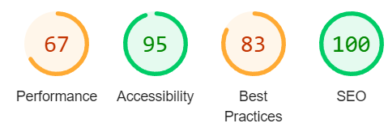

Mobile –



After – webp conv

Desktop –





Mobile –

